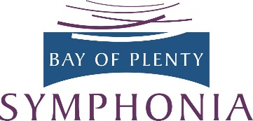
By making a donation or a bequest to Bay of Plenty Symphonia, you’re contributing to the continued musical life of our community and helping young musicians develop their skills. The orchestra needs your support!

BOP Symphonia Inc is a registered charity. Donations of $5 or more may qualify for a tax rebate.

Name
Address

Email Phone
Donation
amount Date
Paid by ☐ Cheque ☐ Cash ☐ Online banking to 03 0435 0458096 00

You can decide if you’d like your donation to be used where funds are most needed or for the purchase of a musical instrument.
I would like my donation to be used:
☐ Where most needed ☐ For purchase of a musical instrument

Please post to BOP Symphonia, PO Box 14073, Tauranga 3143
or email to bopssecretary@gmail.com

