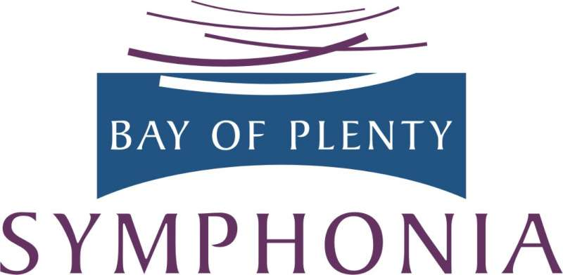

RISING STARS

ARIA COMPETITION 2019

ENTRY Form

Student contact details:

Name |  |  |  | Phone
Mobile |  |  |  | Email
Postal Address
Voice type
Composer and opera / title of aria to be performed
Secondary School I am currently enrolled at
Date of birth
Recommending Teacher

Summary of Musical Achievements and experience:
To enter this competition | Either email or post your entry form to arrive by 5 pm Fri 22nd Febuary 2019  Note: your audition clip for YouTube is not due till later.  See Guidelines for Applicants for full details of the process.

bopssecretary@gmail.com
or Rising Stars 2019, Bay of Plenty Symphonia, P O Box 14 073, Tauranga 3143

