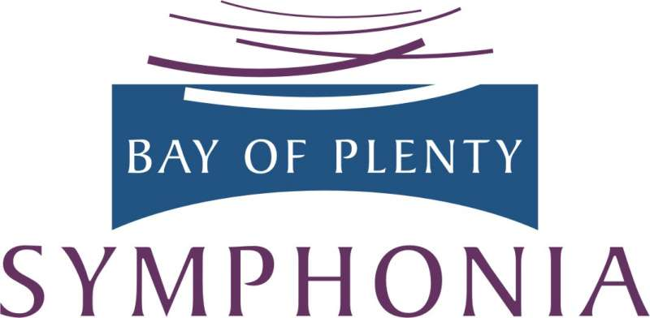
RISING STARS 2023

CONCERTO COMPETITION

ENTRY FORM

Name:

Date of Birth:

Postal Address:

Phone/Mobile:

E-mail address (please write clearly!):

Secondary School I am currently enrolled at:

Instrument teacher:

Instrument:

Composer and title/movement of the piece to be performed:

Summary of musical achievements and experience:

To enter this competition, either e-mail or post this entry form to arrive by 5 pm Fri 3rd March 2023, to bopssecretary@gmail.com or to
Rising Stars 2023, Bay of Plenty Symphonia, P.O. Box 14 073, Tauranga Central 3141

Note: your audition recording is not required until later. See Guidelines for Applicants for full details of the process

